**AP tables=9**

**Columns in Vendor table=12**

**Vendor integer columns=3**

**Vendor character columns=9**

**Vendor primary key=1**

**Vendor foreign key=2**

**AP Database Diagram**

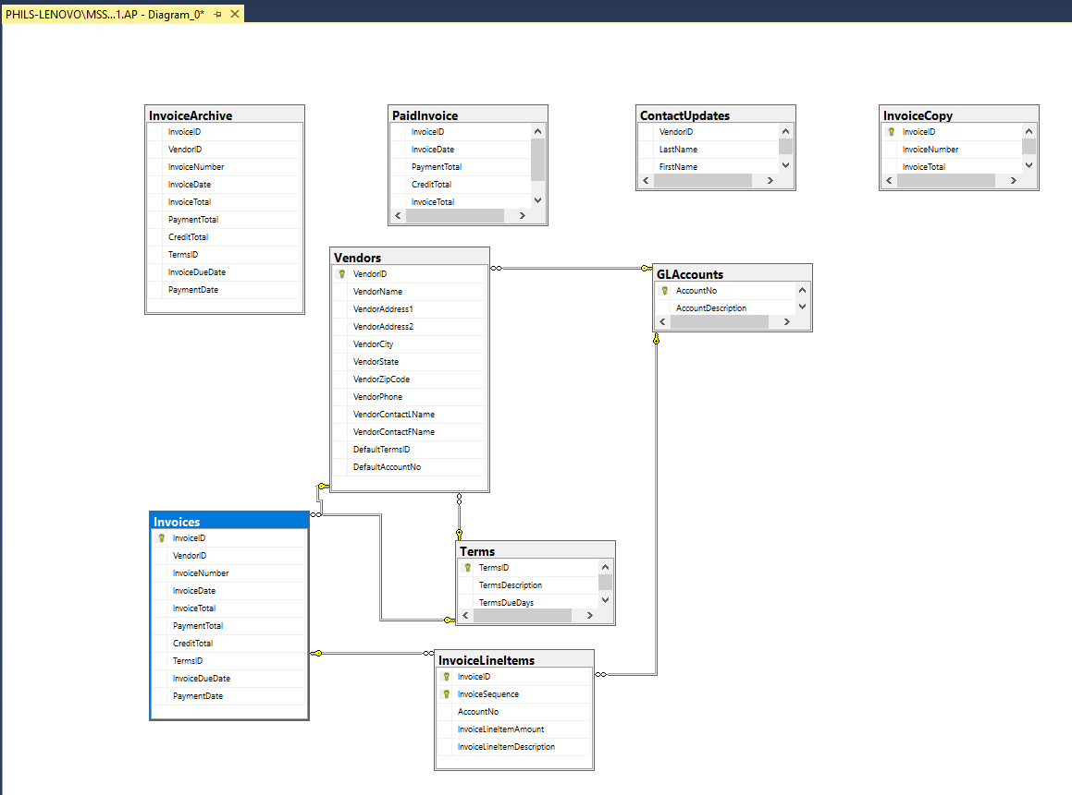

**Terms Table Primary Key=Terms ID**

**Tables related to Terms Table=Vendors and Invoices**

**Terms Table Primary Key data type= Int**

**Column Names of the InvoiceLineItem Table Primary keys (2 keys)= InvoiceID and InvoiceSequence**

**Tables related to InvoiceLineItems Table=Invoices and GLAccounts**

**InvoiceLineItems Table Primary key data type (2 keys)= Int and Smallint**

**Examples Database Information**

a)  How many tables are in the Examples database 22

b)  In the Examples database, how many columns are in the Customers table? 8

c)  In the Examples database, how many columns in the Invoices table have a data type of int? 2

d)  In the Examples database, how many columns in the PaidInvoices table have a data type of money? 3

e)  In the Examples database, how many rows are in the SalesReps table? 5

f) In the Examples database, what is the primary key in the SalesReps table? RepID

g)  In the Examples database, Project table, what is the maximum number of characters allowed in the ProjectNo column? 5

h)  In the Examples database, Projects table, can the ProjectNo column have a value of null? no